**Project Design Phase-II**

**Data Flow Diagram & User Stories**

|  |  |
| --- | --- |
| Date | 19/05/2025 – 30/06/2025 |
| Team ID | LTVIP2025TMID31711 |
| Project Name | HealthAI: Intelligent Healthcare Assistant Using IBM Granite |
| Maximum Marks | 4 Marks |

**Data Flow Diagram:**

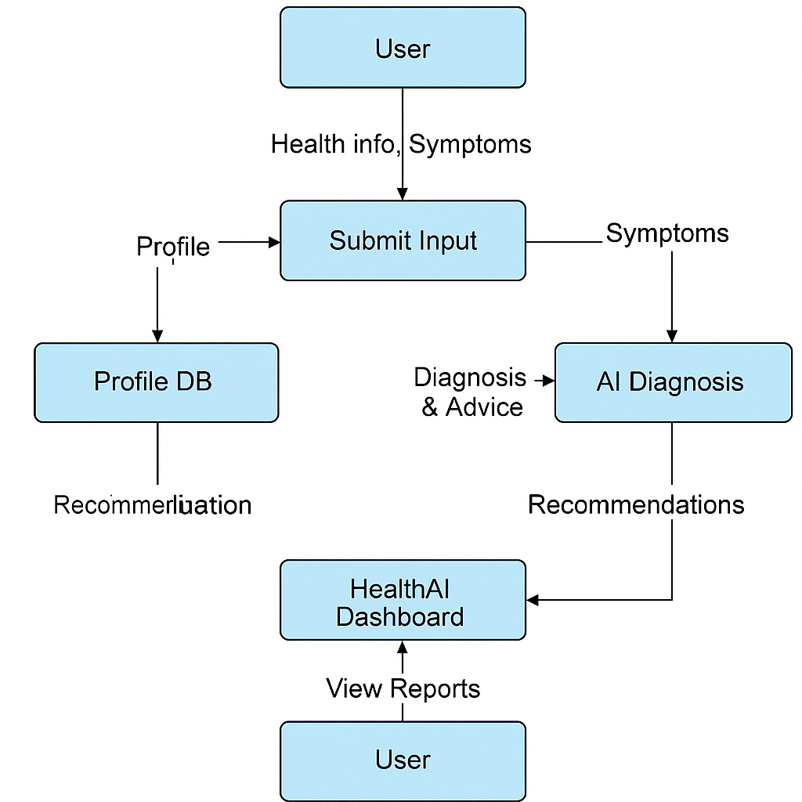

**Data Flows**

* User → Submit Input: Profile, Symptoms
* Submit Input → Profile DB: Store/update personal health data
* Submit Input → AI Diagnosis: Send symptoms
* AI Diagnosis → Treatment Generator: Predicted condition
* Treatment Generator → HealthAI Dashboard: Display advice
* Dashboard → User: View treatment/graphs/histor

**DFD Level 0:**

* **User** → inputs → **HealthAI Interface** → processes → **AI Backend (Granite Model)** → outputs → **Results (Diagnosis, Treatment, Analytics)**
* **User** ↔ **Database** (Profile, History)
* **Backend** ↔ **Email API / External APIs**

**User Stories**

|  |  |  |  |  |  |  |
| --- | --- | --- | --- | --- | --- | --- |
| **User Type** | **Functional Requirement** | **User Story No.** | **User Story** | **Acceptance Criteria** | **Priority** | **Release** |
| User | Profile Setup | USN-1 | As a user, I can register and update my health profile | My details are saved and editable | High | Sprint 1 |
| User | Symptom Checker | USN-2 | As a user, I can enter symptoms and get disease prediction | I receive disease name based on symptoms | High | Sprint 1 |
| User | Treatment Plan | USN-3 | As a user, I can get treatment suggestions based on diagnosis | I see AI-suggested advice and remedies | High | Sprint 2 |
| User | Analytics | USN-4 | As a user, I can view logged data in graph format | I see trend lines of glucose or heart rate | Medium | Sprint 2 |
| Admin | Monitoring | USN-5 | As an admin, I can view system logs and user trends | System reports are accessible | Medium | Sprint 3 |